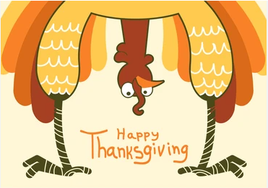

“Hey, this could be our new Thanksgiving tradition.”
You are invited to the 1st Region 4 South AMH…
“Grateful Get-Together”
Date: Tuesday, Nov. 21st
Time: 3:30 – 7:30 p.m.
Place: Hoffman Community Center
127 Main Avenue West
Hoffman, MN

This festive gathering is intended for AMH DIC/Soc consumers from the Region 4 South counties of Douglas, Grant, Pope, Stevens and Traverse – providing an opportunity to socialize and establish new friendships outside usual social circles, share a Thanksgiving meal and enjoy some of the simple pleasures friendship and the season have to offer. This event will include music, games of Corn Hole and “Turkey” BINGO, a “make & take” fall Craft activity, Trivia contest and a supper buffet of some favorite comfort foods. We hope you will join us.
To ensure plenty of comfort food is prepared for all, you must call _________________ to sign up to attend this event by Monday, Nov. 13th. Thank you.

